SAP CIP - ASN0000200
Current Version:
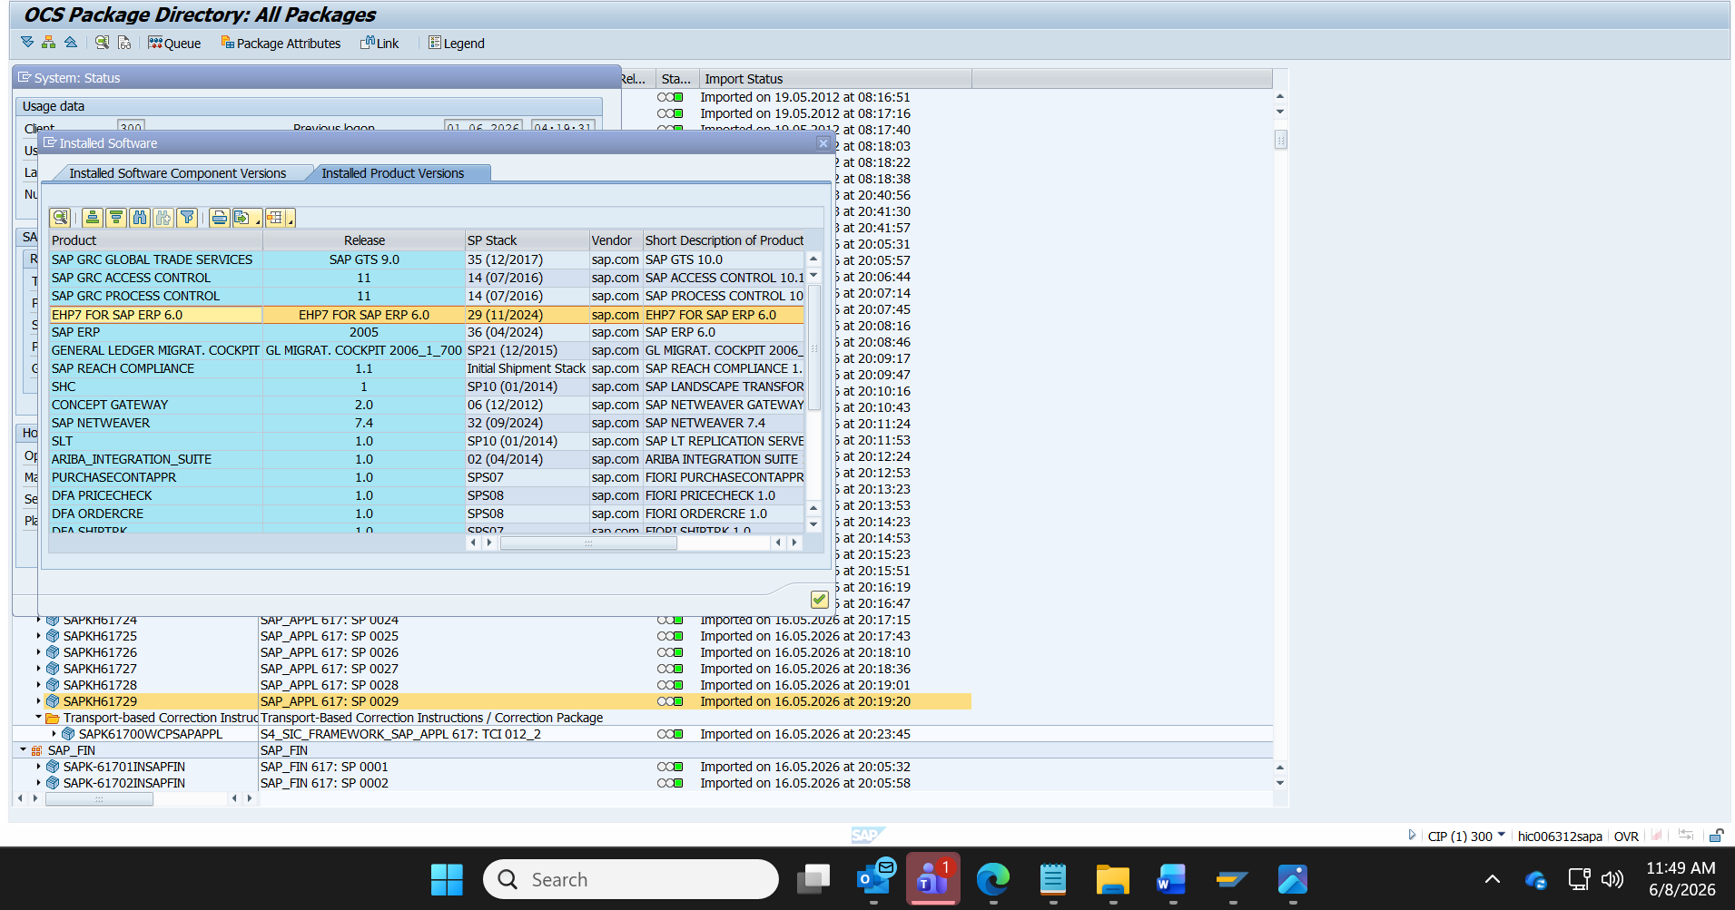
Last updated on:16-May-2026
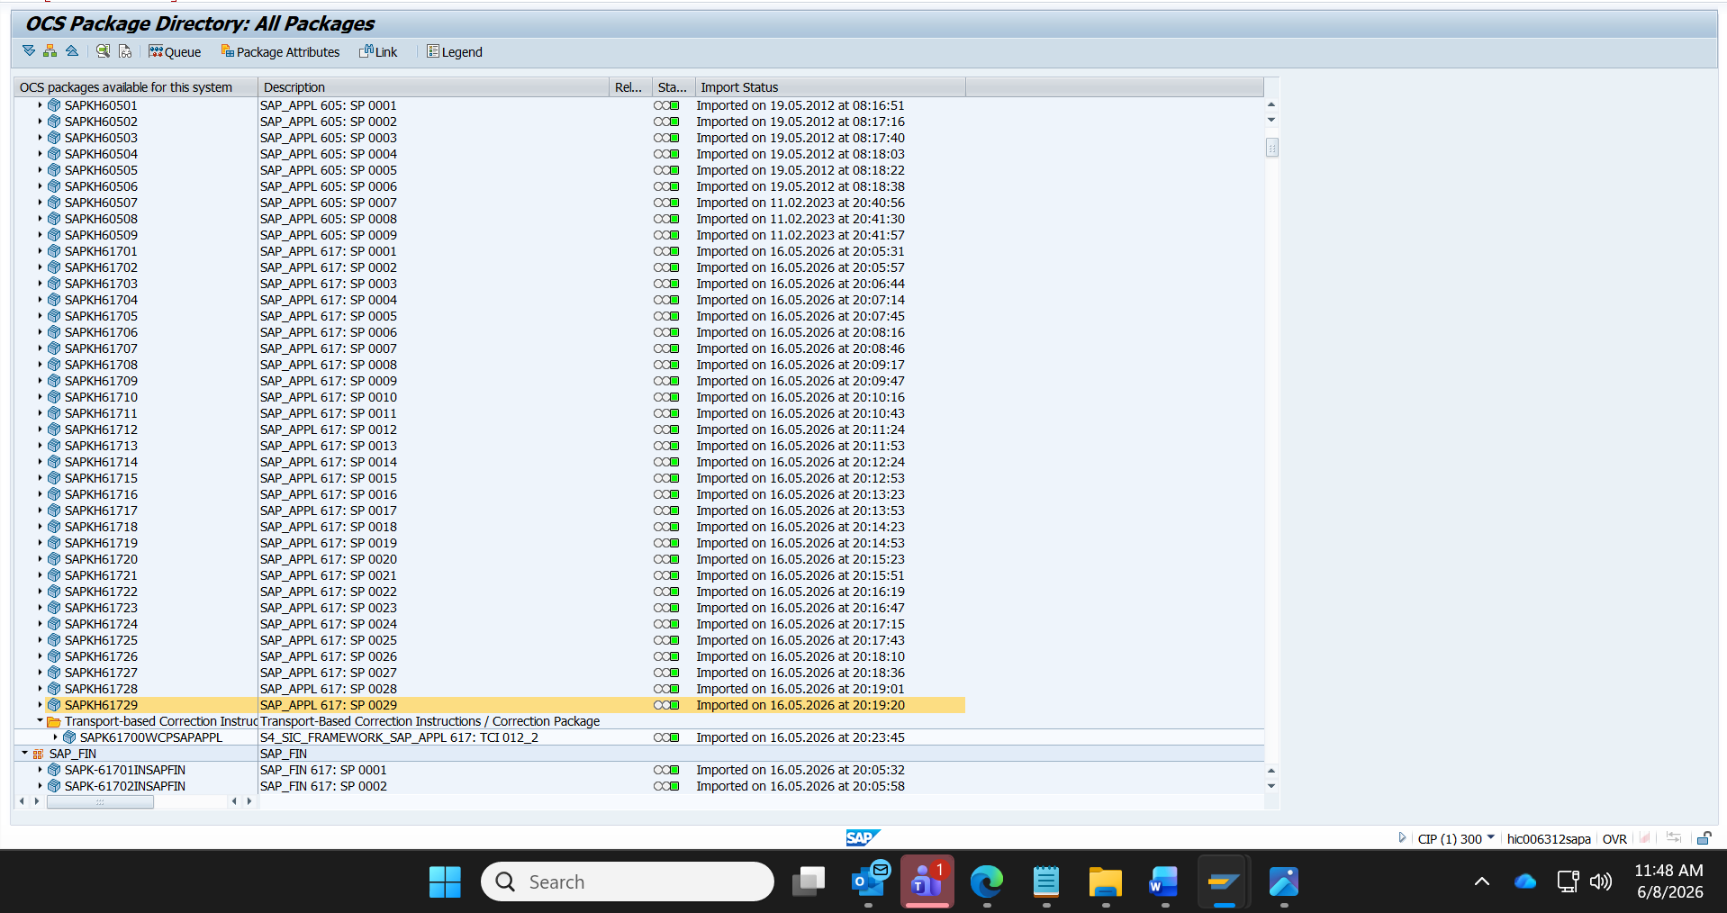
SAP Support End of Mainstream Maintenance: | 31.12.2027
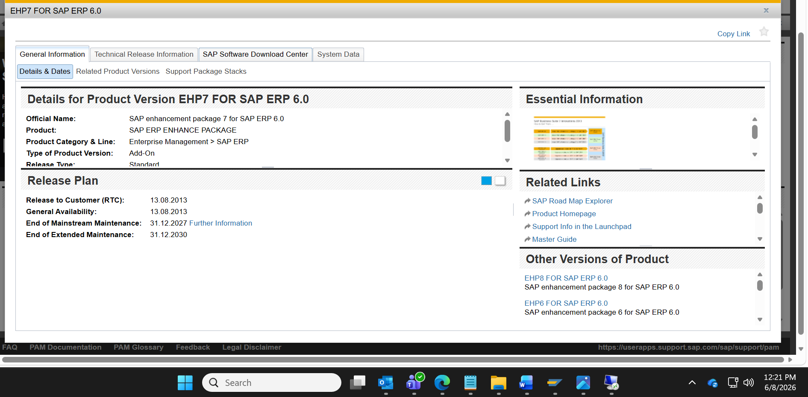

Latest patch available is 32:
